

192.168.8.100/24

ADSL Modem

 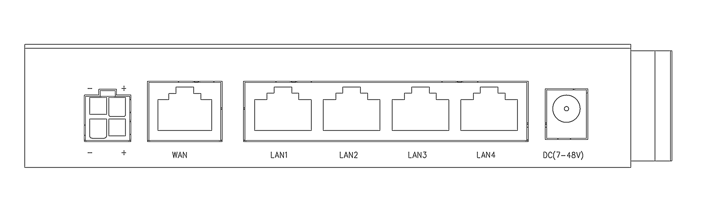

111.221.193.120/32

192.168.8.1/24

111.221.192.1/32

Gateway

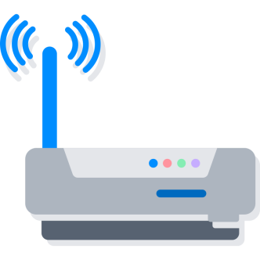



111.221.192.1/16

192.168.8.100/24

Gateway



111.221.193.120/16

Router

192.168.8.1/24





10.6.165.1/24

10.6.165.2/24

192.168.8.100/24



192.168.8.1/24

Gateway



192.168.8.100/24



ADSL Modem

Gateway

111.221.193.120/32

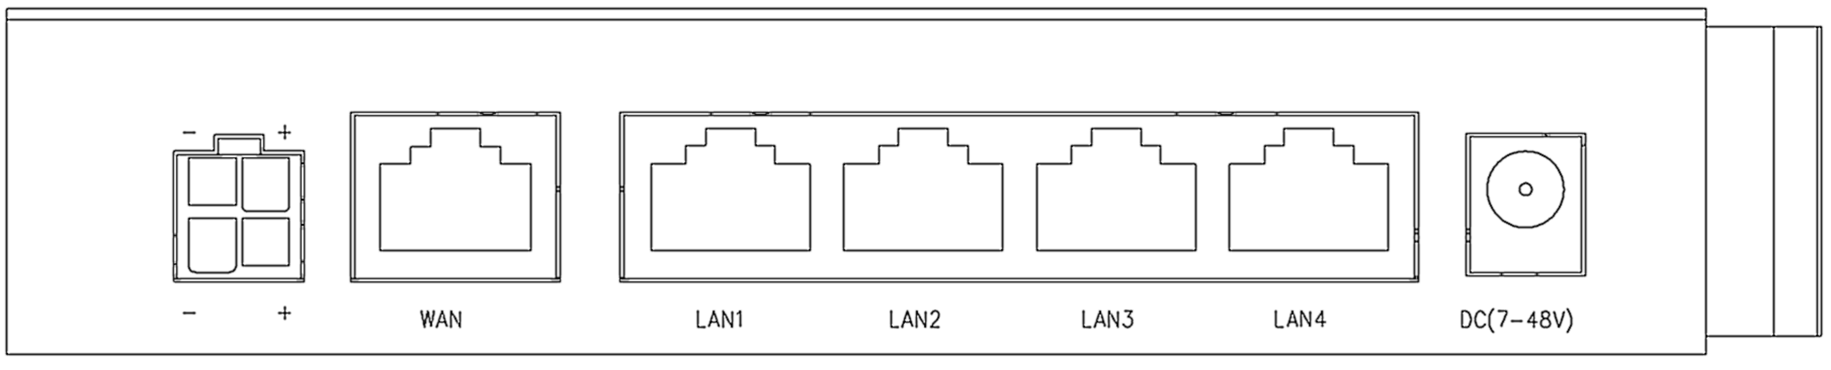

111.221.192.1/32

192.168.8.1/24

Router





192.168.8.100/24

Gateway

192.168.220.60/24



192.168.220.76//24

192.168.8.1/24

192.168.31.120/24



User





Debug

Router

192.168.8.2



Gateway(Repeater Mode)



192.168.8.1

192.168.31.254/24



192.168.31.120/24



User



Debug

192.168.31.254/24



192.168.8.2

Router

Gateway(AP Mode)



192.168.8.1



User



Debug

10.29.16.59/8



192.168.8.2



Gateway(LTE Bridge Mode)



192.168.8.1



192.168.10.1/24

192.168.31.254/24

Router

Router

192.168.8.1/24



192.168.10.134/24

192.168.31.120/24

192.168.8.100/24









Gateway

10.6.165.2/24

10.6.165.1/24



192.168.8.1/24



192.168.8.100/24

192.168.8.101/24





192.168.31.231

172.16.1.1/24

Internet



**192.168.31.1/24**



**111.221.193.120**



Gateway

**WireGuard Tunnel**



172.16.1.10/24



LTE Gateway

**10.95.3.7**





**192.168.8.1/24**

192.168.8.250